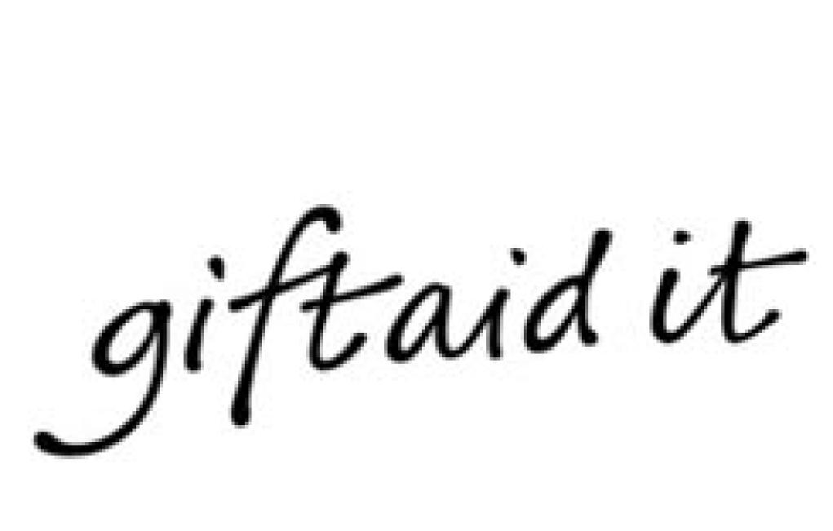
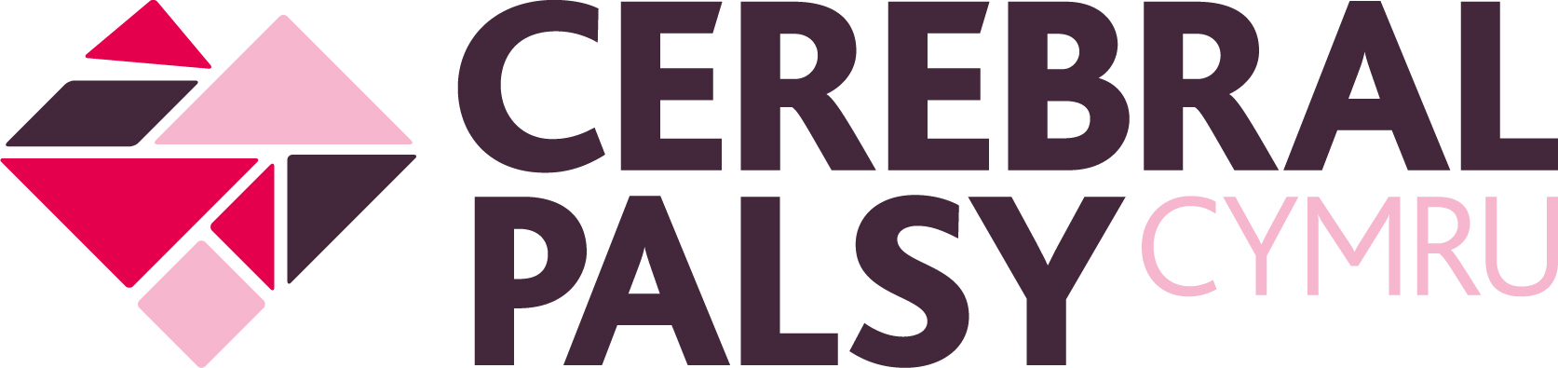

Gift Aid declaration

Cerebral Palsy Cymru

Please treat
All gifts of money that I make today and in the future as Gift Aid donations;

OR

All gifts of money that I have made in the past 4 years and all future gifts of money that I make from the date of this declaration as Gift Aid donations.

Please tick the appropriate box

You must pay an amount of Income Tax and/or Capital Gains Tax for each tax year (6 April one year to 5 April the next), that is at least equal to the amount of tax that Cerebral Palsy Cymru will reclaim on your gifts for that tax year.

Donor’s details

Title _____Forename _________ Surname _______________________

Home address ___________________________________________________

_______________________________________________________________

Postcode _____________________ Telephone ________________________

Email ________________________________________________

Signature ______________ Date _________________

Registered charity: 1010183.

Please notify Cerebral Palsy Cymru if you:

1. Want to cancel this declaration.

2. Change your name or home address.

3. No longer pay sufficient tax on your income and/or capital gains.

Tax claimed

Cerebral Palsy Cymru will reclaim 25p of tax on every £1 you give on or after 6 April 2008.

If you pay income tax at the higher rate, you must include all your Gift Aid donations on your Self Assessment tax return if you want to receive the additional tax relief due to you.

Thank you for helping us make a difference to children and families across Wales living with cerebral palsy.
